This is the error I get:
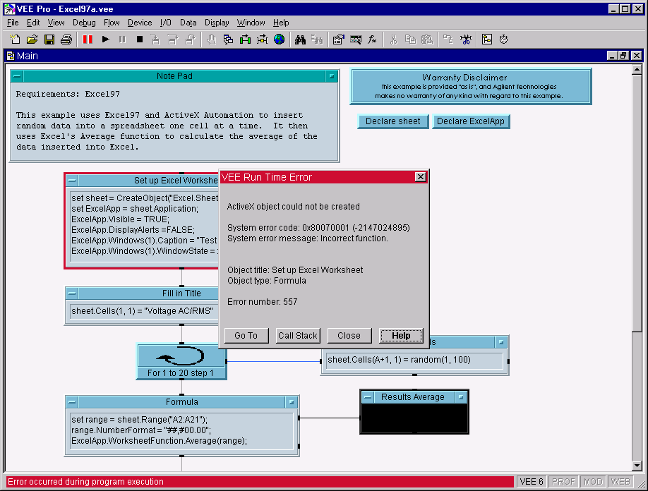

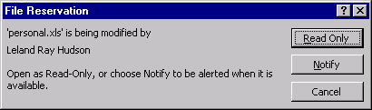
And the next time I try to run the example I get this message in addition to the above error:

