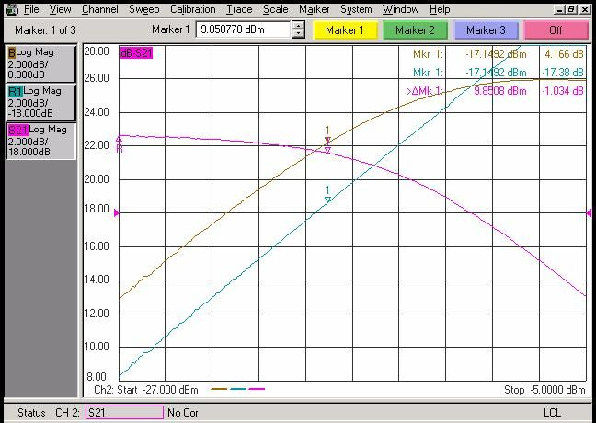

How to write the transaction to set the measurement to power sweep of port 2 ? Can someone send me some examples about how to do this setting using the VEE ? Thanks.

