Installation instructions for the Agilent E5805A 4-port RS-232/USB adapter -

- Download the E5805A driver software from www.agilent.com/find/e5805a --> Drivers and Software.
- Double-click the file you just downloaded; it will unpack the files to C:\Program Files\Agilent\E5805A.
- Plug-in the E5805A.
- Windows will come up with a "Found New Hardware Wizard", select the box "No, not this time", then click Next.
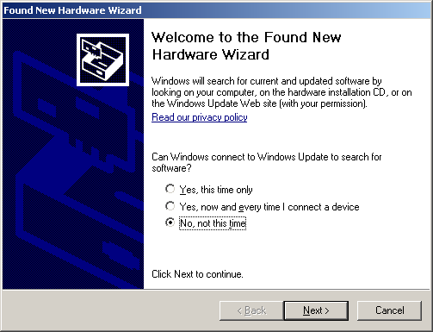
- On the next screen select "Install from a list or specific location", then click Next.
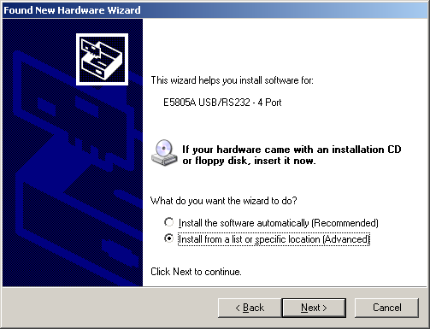
- Check the box that says "Include this location in the search", and give it the path where you unzipped the bits in step 2, e.g. C:\Program Files\Agilent\E5805A. Click Next.
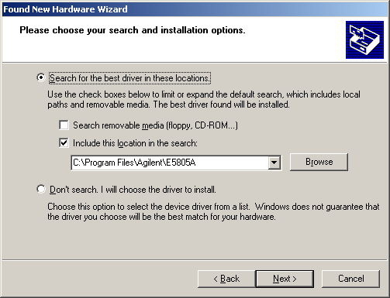
- You will then see a box that says that this driver has not passed Windows testing. Ooooh scary. Click "Continue Anyway".
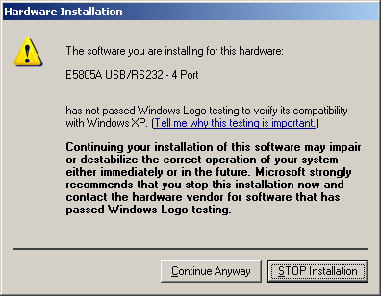
- On the next screen, click "Finish".
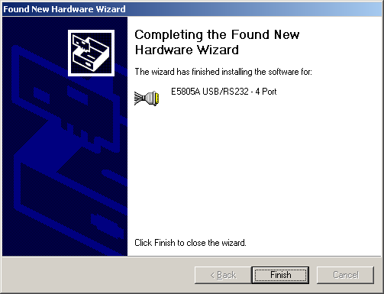
- Repeat steps 4-9 seven more times.
- Open up Connection Expert and you will see 4 new COM ports.

