Software we will need:
- Agilent VEE 7.0
- Microsoft .NET Framework SDK 1.1
- Microsoft .NET Framework 1.1
- Microsoft .NET Framework 2.0
- XAMPP (Apache 2 -server with MySQL distribution)
- MySQL Connector ODBC 5.1.5

We use the MySQL_ODBC example program to connect to our local MySQL server
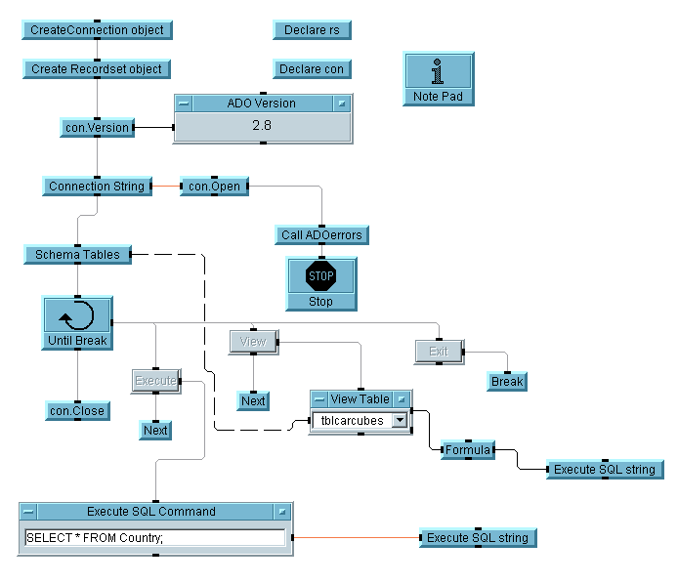

For testing the software we installed Norelec Carcube SQL Database ‘carcube_sav_13_01_2009.sql’ to use as an example.
The database is called punch
To be able to connect to the MySQL database by using ADO we need activate a few ActiveX Automation References.
Select Device, next open ActiveX Automation References.
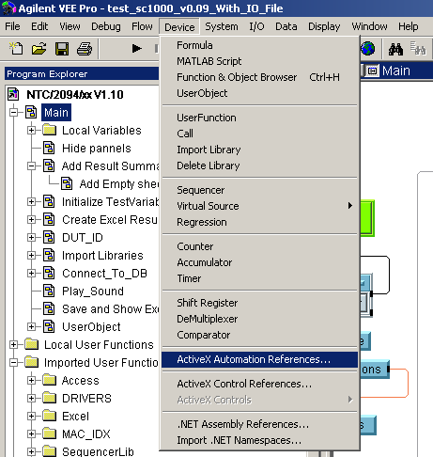

On the next screen tick the box next to:
- Microsoft ActiveX Data Objects (Multi-dimensional) 2.8 Library
- Microsoft ActiveX Data Objects 2.8 Library
- Microsoft ADO Ext. 2.8 for DDL and Security

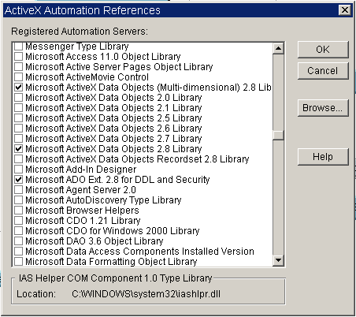

In the MySQL_ODBC program, we now need to redefine the connection string to be able to connect to the local MySQL database.
An ODBC connection string looks like this:
ConnectionString = "DRIVER={MySQL ODBC 5.1 Driver};"
"SERVER=localhost;"
"DATABASE=test;"
"USER=venu;"
"PASSWORD=venu;"
"OPTION=3;"

The connection string from the sample should be modified as follows:

User ID=root;
DRIVER={MySQL ODBC 5.1 Driver};
DATABASE=punch;
SERVER=localhost;
UID=root;
PASSWORD=admin;
PORT=3306;

To connect to a remote server the SERVER property should contain the IP Address of the MySQL server. Also; the password given here is the password of our local server; this can be different on another system.

When the connection string is completed correctly it is possible to run the program. The program will now connect to the provided database (here punch) and will list the tables that are available in this database. In the example we have the following tables:
tblcarcubes
tblcarcubesol2
tblcarcubesold
tblcarcubetestrapport
tblhmi
tblhmi2
tblproductiondeliverynotes
tbltestdefaults

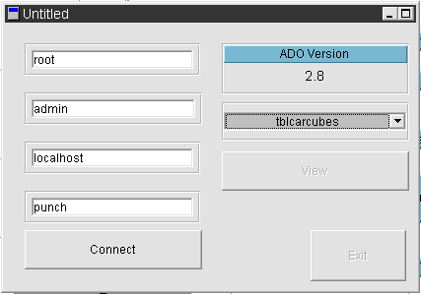

It is now possible to execute a query on one of these tables or to view the contents of them.
If we choose to view the tblcarcubes table we receive an overview of its contents:
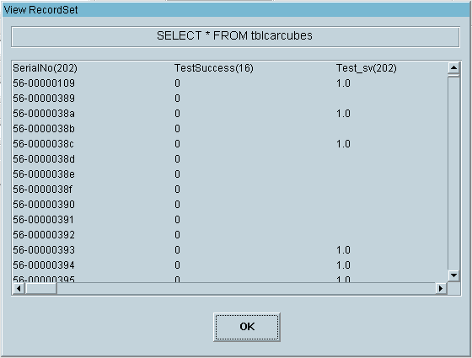
We can now optimize the program to be able to connect to any database we want. To do this we will add input text fields and a formula field which will replace the connection string.
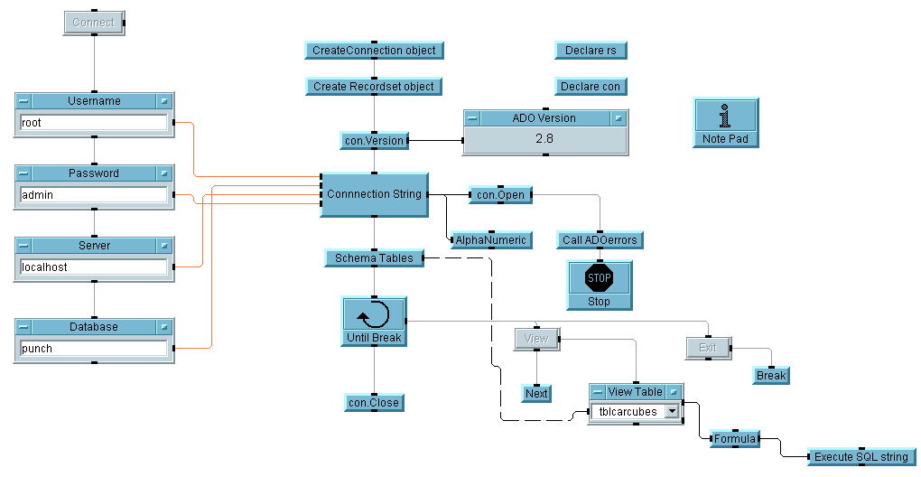
The formula field contains the following code to be able to generate a connection string based on the info from the input fields:
"User ID="+user+";DRIVER={MySQL ODBC 5.1 Driver}; DATABASE="+db+"; SERVER="+server+"; UID="+user+"; PASSWORD="+pass+"; PORT=3306;"

With this sample program we can now access a MySQL database through VEE. It is now possible to modify this sample to be able to add records to the MySQL database. This will be the next step.

