/*=========================================================================

| GENERAL API

========================================================================*/

/*

* Get a list of ports to which Aardvark devices are attached.

*

* nelem = maximum number of elements to return

* devices = array into which the port numbers are returned

*

* Each element of the array is written with the port number.

* Devices that are in-use are ORed with AA_PORT_NOT_FREE (0x8000).

*

* ex. devices are attached to ports 0, 1, 2

* ports 0 and 2 are available, and port 1 is in-use.

* array => 0x0000, 0x8001, 0x0002

*

* If the array is NULL, it is not filled with any values.

* If there are more devices than the array size, only the

* first nmemb port numbers will be written into the array.

*

* Returns the number of devices found, regardless of the

* array size.

*/

#define AA_PORT_NOT_FREE 0x8000

int aa_find_devices (

int num_devices,

u16 * devices

);

/*

* Get a list of ports to which Aardvark devices are attached.

*

* This function is the same as aa_find_devices() except that

* it returns the unique IDs of each Aardvark device. The IDs

* are guaranteed to be non-zero if valid.

*

* The IDs are the unsigned integer representation of the 10-digit

* serial numbers.

*/

int aa_find_devices_ext (

int num_devices,

u16 * devices,

int num_ids,

u32 * unique_ids

);

Aardvark GUI Configuration Screen

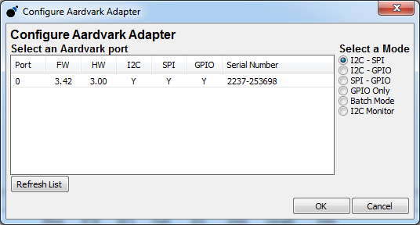

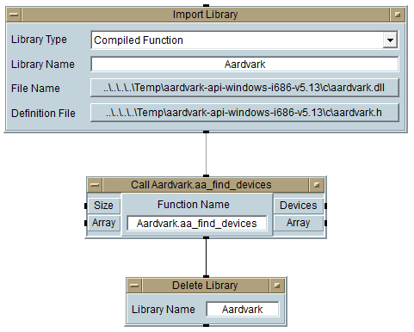

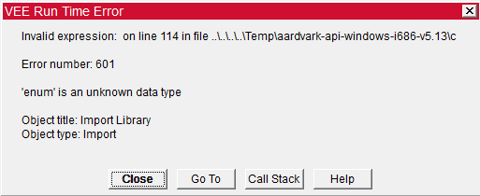

**Line 114:**

enum AardvarkStatus {

/* General codes (0 to -99) */

AA_OK = 0,

AA_UNABLE_TO_LOAD_LIBRARY = -1,

AA_UNABLE_TO_LOAD_DRIVER = -2,

AA_UNABLE_TO_LOAD_FUNCTION = -3,

AA_INCOMPATIBLE_LIBRARY = -4,

AA_INCOMPATIBLE_DEVICE = -5,

AA_COMMUNICATION_ERROR = -6,

AA_UNABLE_TO_OPEN = -7,

AA_UNABLE_TO_CLOSE = -8,

AA_INVALID_HANDLE = -9,

AA_CONFIG_ERROR = -10,

<aardvark>

<configure i2c="1" spi="1" gpio="0" tpower="1" pullups="0"/>

<spi_bitrate khz="250"/>

<spi_write count="5" radix="16">02 C0 00 00 00</spi_write>

<!--LOCKED(0), LOOP_POLARITY(1),2=Pos, 0=Neg -->

<sleep ms="100"/>

<spi_write count="5" radix="16">03 00 00 00 00</spi_write>

<!--OFFSET(0), PD_PLL(1), PFD_PLLn(2),0=PFD/Offset, 6=PD/Offset -->

<sleep ms="100"/>

<spi_write count="5" radix="16">03 40 00 00 00</spi_write>

<!--PLL_SHORTn(0), LLF_SHORTn(1), 0=loop locked? -->

<sleep ms="100"/>

</aardvark>